Lab 10
Configuring Dynamic Routing (OSPF, EIGRP, RIP) and Redistribution of Routing Protocols
Objectives:
How to configure dynamic routing protocols like OSPF, RIP and EIGRP on routers
Configure OSPF, RIP and EIGRP routing protocols in separate domains
Implement route redistribution between OSPF and EIGRP, EIGRP and RIP, vice versa
Verify connectivity across both routing domains
Verification and troubleshooting of routing protocols
Dynamic routing
Dynamic routing is known as a technique of finding the best path for the data to travel over a network in this process a router can transmit data through various routes and reach its destination based on conditions at that time of communication circuits.
OSPF (Open Shortest Path First)
OSPF is an interior gateway protocol (IGP) for routing Internet Protocol (IP) packets within a single routing domain, such as an autonomous system. It gathers link state information from available routers and constructs a topology map of the network. The topology is presented as a routing table to the internet layer which routes packets based solely on their destination IP address.
EIGRP (Enhanced Interior Gateway Routing Protocol )
Enhanced Interior Gateway Routing Protocol (EIGRP) is an advanced distance-vector routing protocol that is used on a computer network for automating routing decisions and configuration. EIGRP is used on a router to share routes with other routers within the same autonomous system. Unlike other well known routing protocols, such as RIP, EIGRP only sends incremental updates, reducing the workload on the router and the amount of data that needs to be transmitted.
Redistribution of Routing Protocols:
Route redistribution is the process of sharing routing information between different routing protocols. It's essential in networks where multiple routing protocols coexist, often due to:
- Company mergers
- Departmental preferences
- Network migration
- Technical requirements
Key Concepts:
- Redistribution Points
- A router running both protocols acts as a redistribution point
- This router is called an Autonomous System Boundary Router (ASBR)
It translates routes between protocols

Configuring OSPF on routers in Cisco packet tracer
First design the given topology and assign the appropriate ip’s as shown in figure
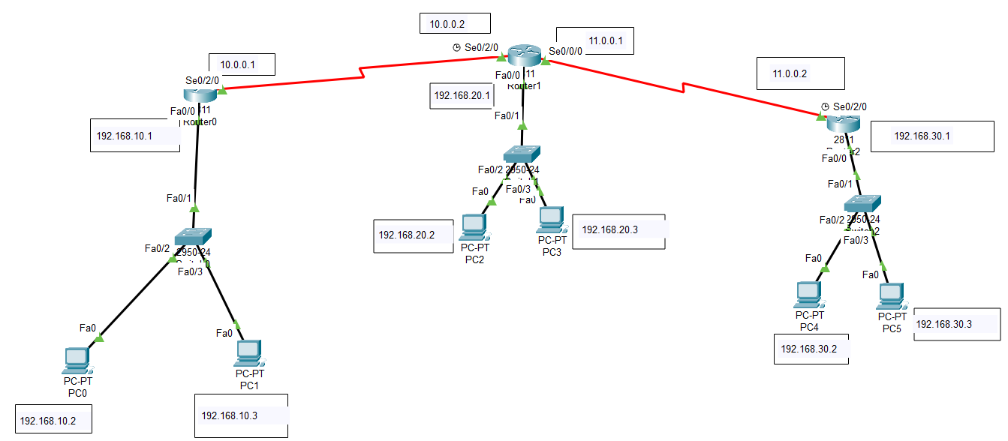
Figure 01
Click on router 0 and enter into cli and type below commands for OSPF configuration. After typing these commands press ctrl+z to save the settings
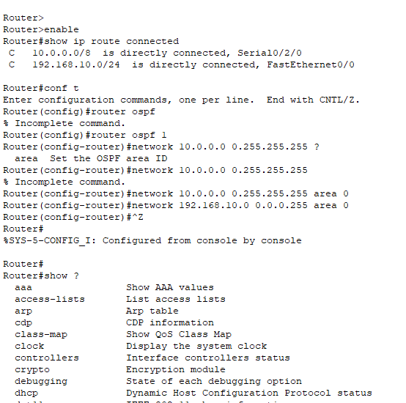
Now enter into router 1 cli and type below commands
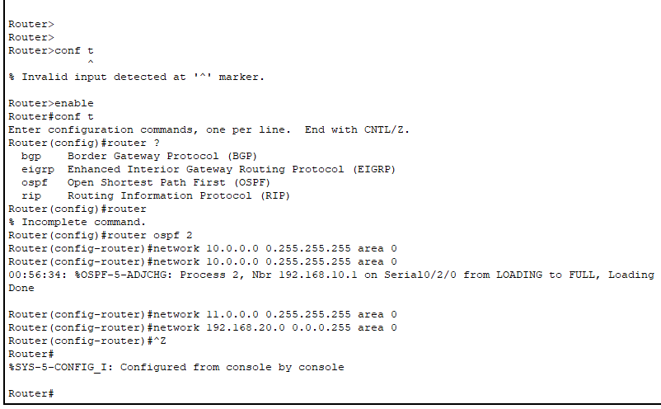
Now click on router 2 and type below commands
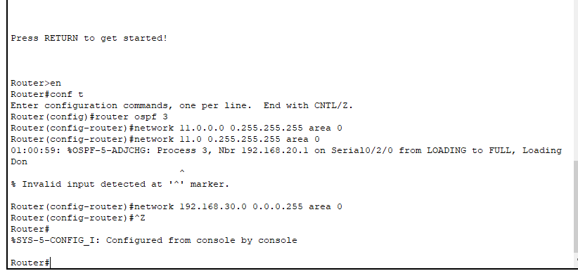
Show ip route
Command we can check that ospf is configured on routers
Now ospf is configured on all the routers and all the devices should be able to ping each other

Configuring EIGRP on routers in Cisco packet tracer
Draw the topology shown in figure 01
Click on router 0 and type below commands to configure eigrp protocol
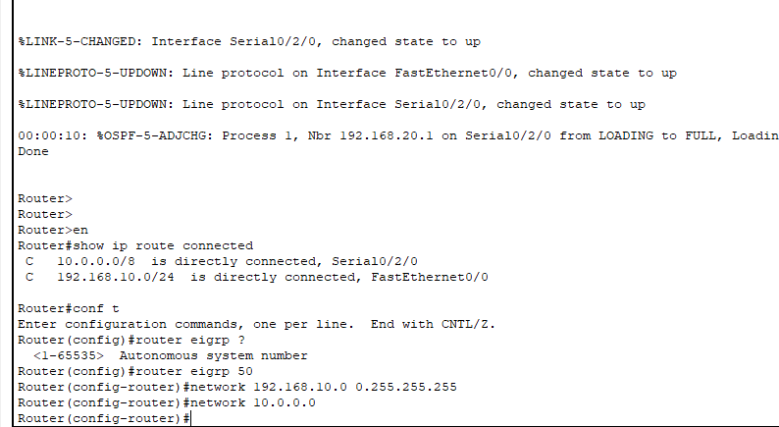
Same do configuration for router 1 and router 2
Make sure that Autonomous system number of eigrp is same on all routers
After configuring EIGRP on all routers check the connectivity of all devices

Configuration for Redistribution of OSPF and EIGRP:
Draw the network topology in cisco packet tracer as shown in figure given below
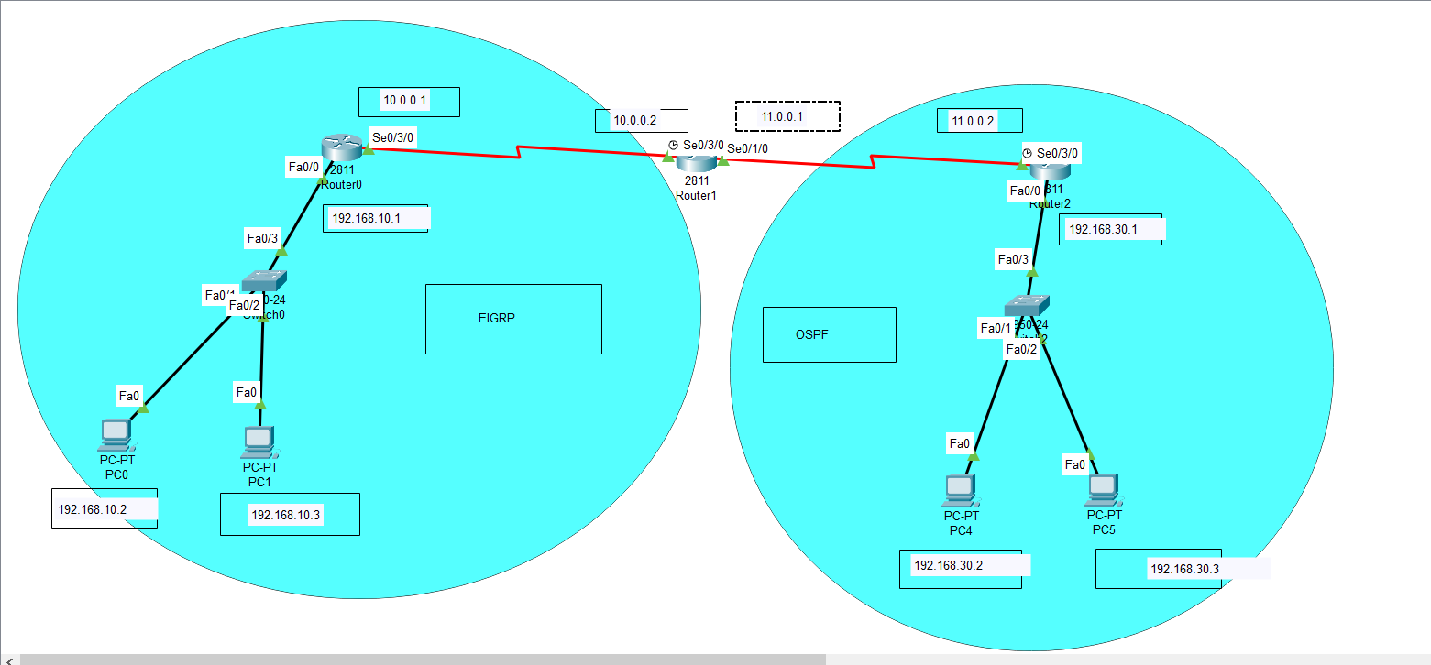
Figure 02
Router 0:
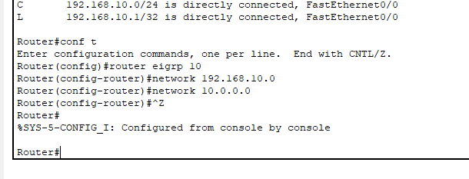
Router 01
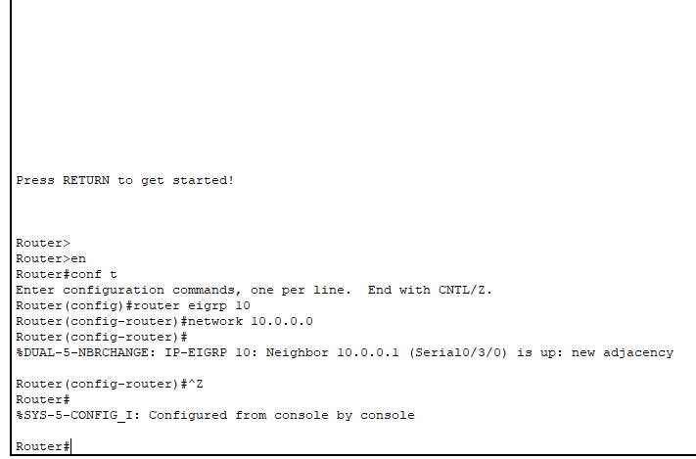
Router 01
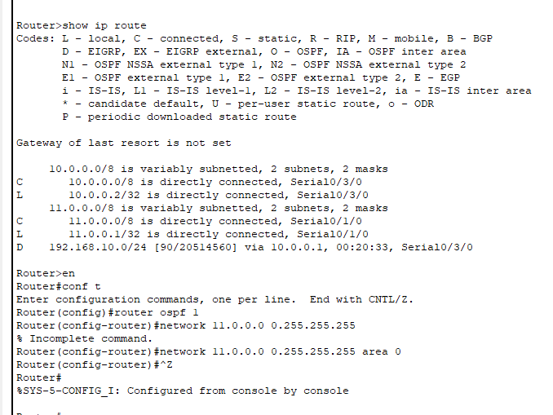
Router 02
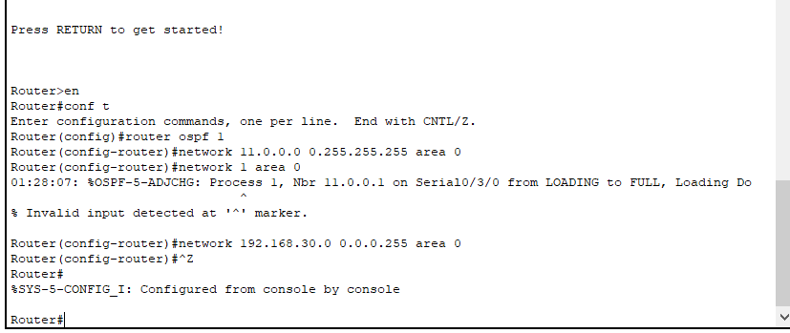
Router 01
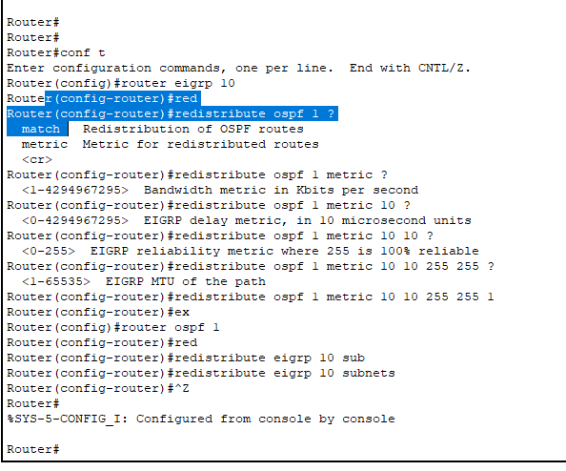
After doing the above configurations for the redistribution of various routing protocols then the devices from one network should be able to communicate with the device from the other network.

TASKS
- Configure OSPF routing protocol in network topology given in figure 1 [2.5 marks]
- Configure EIGRP routing protocol in network topology given in figure 1 [2.5 marks]
- For the given topology in figure 02, Perform the redistribution of OSPF and EIGRP routing protocol on Router 01 and verify the connectivity of different networks. (2.5 marks)
- For the given topology in figure 02, Perform the redistribution of RIP and EIGRP routing protocol on Router 01 and verify the connectivity of different networks. (2.5 marks)

